Social Media Marketing Campaign Proposal for Nike
Student’s Name
Institutional Affiliations

Social Media Marketing Campaign Proposal for Nike
Introduction
Nike is a household name in sports. The company has practically sponsored sports activities from golf, tennis, basketball to football. In shifting in-depth attention to what Nike has been striving on in marketing, one can envisage a room for a proposal that will last for decades in profitability. This paper proposes a strategy for digital marketing that has since been forgotten by the company. It is a proposal for the company to partner with high school institutions across populated cities in the United States. This proposal is based on the objective of the use of partnerships to create digital awareness among teenagers who, according to the Bureau of Statistics, are the largest population across the United States lifespan index. Nike has continuously sponsored well-known athletes and produced innovative sports essentials. It has also used technology to predict and create products tailored to customer needs. For this paper, partnering with high schools across populated cities and states is stemmed from the millennial proliferation in using smartphones. Partnering with high schools is a strategic social media campaign aimed at establishing long term marketing techniques among the youth. Most eminently, working with youth amidst technological advances is the new threshold of digital marketing for success.
Company Background
Nike is a sportswear company that was started in 1964 under the proprietorship of Bill Bowerman and Phil Knight. The company specifies in athletic wear, footwear, accessories and apparels as indicated by Hoffmann, Batchelor & Manning (2016). Over the years, Nike has used both traditional and digital strategies to market its products. In the year 1982, the company made its debut television advertisement that centered it as a prime sports utility company with a range of advantages for athletes and sportsmen.
In addition, the company is currently using collaboration with high-tech corporations to effect prototype design shoes that are custom-maid for the needs of consumers. It is an innovation technique partially linked to customer emotional branding and attainment of competitive merit in the global market. The company particularly partnered with Dell EMC in 2017 to showcase a virtual imprint of what technology-assisted marketing can create. According to Araujo, Caldwell & DeFanti (2018), the results from this collaboration was in skyrocketing sales as illustrated in appendix 1.
Situation Analysis of Nike
Nike’s growth and competitiveness are steered from its internal work culture captured by the caption “Just Do It” as shown in appendix 2. It is a company driven by values bestowed in diversity in the workforce and brand image through its Human Resource programs like “Speak Up!” This phrase calls for idea sharing in problem-solving and decision making. Many of the company subscribers have likened the values and culture of the company to limitless possibilities in innovation. Furthermore, the company has wedged out competitors through the utilization of emotional branding of fans’ favorite sportsmen and women’s names on jerseys it produces. According to (Brohi et al. 2016), the company has also created and nicknamed shoe samples or models like Jordan after legendary basketball player, Michael Jordan.
This marketing approach, empowered by frequent employee training, has qualified the company to stay ahead of the competition against similar companies like Adidas. The strategies have been the company’s strengths and opportunities. The only weakness the company has had in the recent past is its lexical value phrases such as “Move to Zero” in attestation to approaches of saving the environment from carbon emissions in the company’s industries (Pandey, 2017). The pragmatics behind these phrases has placed the company in the spotlight of criticism on its sensibility to issues pertaining to environmental pollution and conservation (Childs & Jin, 2018).
Campaign Objectives for the Proposal
The objective of the proposed social media campaign is to partner with densely populated city high schools where more than average populations of students use smartphones more frequently than adults. Firstly, upon partnering and subsequently sponsoring interschool games, the company should be able to double its number of online subscribers by 100% between twenty to thirty minutes per company’s online page visitation. This is a SMART objective because it is measurable. If the number of page visits does not double the original number before implementation of the proposal, then a review should be done on the objective. Secondly, the campaign should enable the company to get approximately 2000 new subscriptions in a period of two months subject to review. The millennials are the new digital marketing advantage. Therefore, tapping in their midst from the teenage years is a prospective market for decades.
Lastly, the proposal is guided by the objective that by the end of twelve months after the implementation of the proposal, the company should be able to generate revenue of more than a quarter of its total annual revenue of the previous fiscal year. Because this proposal offers a new market orientation targeting a particular group that is dependent on working members of the society, measuring the target revenue against a quarter of the previous year’s revenue is in consideration of many factors. Factors such as economic backgrounds of the school-age teenagers determine accessibility to smartphones and timely information.
Target Audience of the Proposal
This campaign proposal aims to reach young school-age school students. It seeks to cement Nike’s brand among the upcoming sportsmen and women who are in their adolescence. By strategically being a school partner, the company adopts a new market on top of the prior partners. As shown by Hoffmann, Batchelor & Manning (2016), millennials are the current popular culture that design and textile companies crave to achieve leverage over.
Psychologists posit a correlation in peer influence among teenagers. As the proposal targets the senior high school students, it shall simultaneously influence the perception of junior and college students. When reinforced by additional standards of marketing such as children open fun days, the company shall reach the biggest population among the youths across the United States. It is a psychological concept governed by peer social networks to imitate and pursue what fellow colleagues are up against.
Conclusion
Nike has done tremendously well in monopolizing sportswear companies in the market. Due to its flexibility in adopting technology and customer needs, it has very easily stayed on top of the competition. The company’s greatest market base has been seen in sponsorship programs that targeted athletes and renowned sportsmen as the brand ambassadors for the company. A proposal of a new approach to an even greener niche of the customer base lies in the dissemination of the company’s information to the teenagers. Partnering with schools is the best method to reach out to this slumbering and vivacious market. Indeed, and most eminently, working with youth amidst technological advancements is the new threshold of digital marketing for success.

References
Araujo, D., Caldwell, H., & DeFanti, M. (2018). Nike’s Utilization of Brand Strategy to Increase Global Competitiveness. In Competition Forum (Vol. 16, No. 1, pp. 109-115). American Society for Competitiveness.
Brohi, H., Prithiani, J., Abbas, Z., Bhutto, A., & Chawla, S. (2016). Strategic Marketing Plan of Nike.
Childs, M., & Jin, B. (2018). Nike: An Innovation Journey. In Product Innovation in the Global Fashion Industry (pp. 79-111). Palgrave Pivot, New York.
Hoffmann, F., Batchelor, R. P., & Manning, M. J. (2016). Nike and Popular Culture. In Basketball in America (pp. 63-76). Routledge.
Pandey, B. C. (2017). Nike Inc-Complete Analysis: SWOT, PESTLE and Marketing strategy. BookRix.

Appendices
Appendix1. This is the company’s situation analysis in accordance with SWOT analysis.
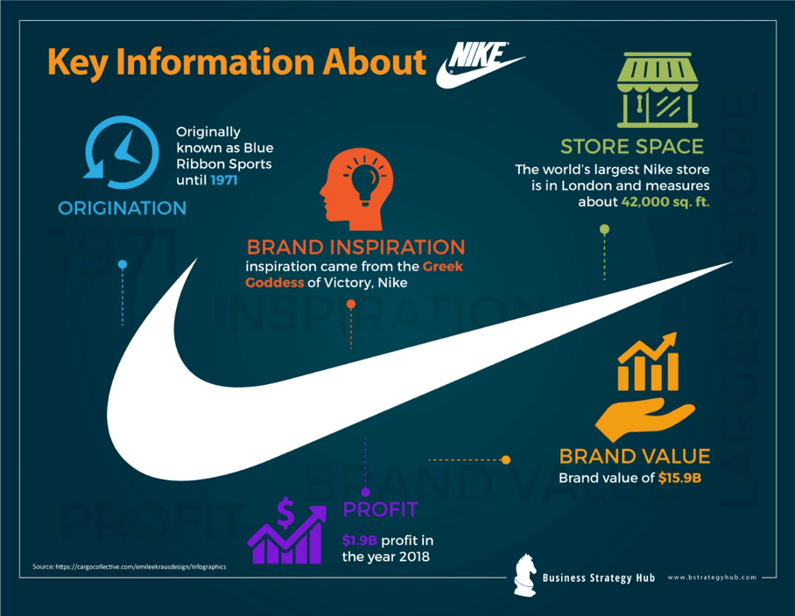
Appendix2. This is the illustration of the company’s culture and value.
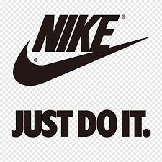
Nikes ad celebrating Farah


